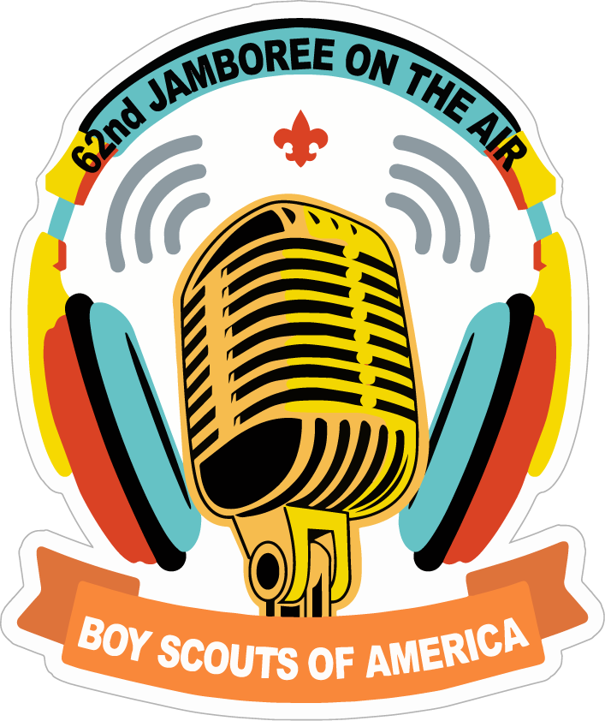
JOTA 2019

Running a Successful
JOTA Event Station
Oct. 19, 2019

Compiled from K2BSA and Other Sources
By Douglas Sharafanowich – WA1SFH
ARRL Section Youth Coordinator - Connecticut
203-494-3885
ConnecticutSYC@gmail.com

Jamboree On The Air (JOTA)
Jamboree On The Internet (JOTI)
Running a Successful JOTA Event Station (2019)

Index
CHAPTER | PAGE
1. Overview | 3
2. Mission – Method - Objective – Goal | 4
3. Dress Code | 5
4. Event Report | 6
5. The Station | 7
6 Make a JOTA QSL Card | 11
7. Sample Station ID Sheet to Post | 12
8. JOTA Operating Rules | 13
9. Radio Topics to Cover | 14
10. Not a “Contest” | 19
11. How to Call CQ | 20
12. JOTA Calling Frequencies (+/-) | 21
13. 3rd Party Agreements & Scouting Countries | 27
14. Support Materials | 29
15. Let’s Have a “Conversation” | 30
1. OVERVIEW
Thank you for volunteering to help with JOTA 2016.
JOTA is a spectacular opportunity to introduce Scouts to amateur radio. For many, this will be their first exposure to the world of ham radio.
- Some will go on to become hams, enjoying the hobby for a lifetime.
- A few will even find the basis of a career in science and technology.
This document has been compiled from various sources (K2BSA.net and others) to help you have a successful JOTA /JOTI (“JOTA”) event.

As you read through the material and then experience JOTA 2017, please share with me your ideas on how this documemnt can be improved.
If you want to do something different, please go ahead and DO IT !
All I ask is that you let me know 3 things:
(1) What you did, (2) How you did it, and (3) What the results were - Good or Bad.

JOTA is NOT a “Competition” or “Contest”
The idea is to contact other Scout stations and allow as many Scouts as possible to talk to other Scouts and learn about who they are and what they are doing. You might think about counting the Scouts on both sides of the QSO rather than the number of QSOs!

Photograph the Event - Have a designated Station Photographer
Photos help catch the essence of your JOTA operation. While photos of your equipment and antennas can be interesting for ham radio operators, they don't tell the story of your operation. That takes photos of Scouts in action, ideally with smiles or expressions of discovery.

Best shots are facing the scouts taken from behind the radio.
Avoid shots from the rear/rear quartering (compare my letterhead pictures).
- Get Names with Pack/Troop/Venture Number for later Photo Release follow-up requests.

Publicity

You're encouraged to send news releases of the event to your local newspapers and television and radio stations. You can encourage photographers to attend the event. You can also forward photos to your local news media, including weekly papers. A sample news release is included on this website. For more on publicity, see Scouting Publicity Guide

2. MISSION - METHOD - OBJECTIVES - GOAL

MISSION
(a) To introduce Scouts to magic of Amateur Radio,
(b) To facilitate “On-The-Air” Conversations with other Scouts,
(c) To identify individual Scouts who “signal” (visible excitement) that they want to go further with Amateur Radio for follow-up.
METHOD
Avoid Scout BOREDOM!
USE: “Total Participant Involvement (TPI)”
- Give brief ‘Top-Level” (Non-Technical) instruction on Radio basics
- Engage Scouts in physical demonstrations of Radio Concepts
- Teach and Quiz scouts to prepare them for the “On-The-Air” experience.
- Run Practice simulations.
- LIMIT the size of groups at the radio to NOT MORE THAN 6

OBJECTIVES
Introduce Scouts to the joy of Amateur Radio and give them the opportunity to talk on the radio.
We want to:
Plant a Seed - Build Excitement - Spark the Dream.

GOAL
To “Share The Magic” AND Have Fun!

3. DRESS CODE
Look Sharp!
Our appearance is really, really.... REALLY IMPORTANT.

YOU ARE “Ham Radio”
For good or bad, you represent all Amateur Radio Operators to:
Scouts, Adult Scout Leaders, BSA Council Staff AND Parents .

Perception is Reality
You are giving them a glimpse into the type of people the kids can expect to be around in our hobby. So, “Looking Good” is really important to our mission of cultivating future Ham Prospects and creating a positive image of Amateur Radio.
Personal Appearance (Suggestions)
- Get a Haircut if your mane is looking shaggy.
- Come Showered and Shaved (and/or with Beards neatly trimmed).

Clothing
Please wear clothes that are clean and that make you look and feel “sharp”.
If you are an Adult Scout Leader, please wear your “Class A” uniform.

Clothing Ideas:
- Amateur Radio Club Jackets,
- Hats with Callsigns,
- Amateur Radio related Shirts (e.g. Field Day)
- ARES Vests and Caps
- ID Tags with Callsign and Name

Optional
Spit-shined boots/shoes LOL!

Watch the Weather Forecasts
- It is bound to be chilly in the morning. (Think: “Layers”)
- It might be “wet”.
- Typically, there is no snow in the forecast.
Everyone: Bring an HT (Analog)

4. JOTA Event Report

- Capture The Numbers!
The big key for JOTA is to capture key numbers for your report at the end of the day.
HINT: APPOINT SOMEONE to take care of the counts.
Key Numbers include:
- Number of Scouts at your JOTA Activity Station(s)
- Number of Visitors (non-Scouts/family members) coming through
- Number of Stations On-the-Air at your JOTA site.
- Number of Amateur Radio Operators participating at your JOTA site.
- Number of Contacts/QSOs (again: this is NOT A CONTEST).
- States Contacted (Number and Names)
- Countries Contacted (Number and Names)
(The last few items can be determined from your logbook.)
The others will need a reasonable assessment of the traffic through your station.
* Report Form attached at back of this document*
Station Registration
Please register your JOTA station with K2BSA
https://k2bsa.net/jota-station-registration/
Please send me a copy of your “JOTA” report
Douglas WA1SFH
connecticutSYC@gmail.com

Thank you.
Scout Participation Log
You will want to start a separate Log sheet of Scouts (First Name, Den #, Pack #, Troop #, Crew #) who became really excited about Amateur Radio.

This will be helpful in talking with their Scout Leaders to follow-up with scouts to take the next step and/or do something with their Cub Scout Den/Pack, Boy Scout Troop, or Venture Crew.

5. The Station
One Callsign
No matter how many stations you run at a JOTA event, use only one Callsign for your JOTA event.
The Magic # is 6
Over the years, we have tried several approaches for getting Scouts “On-The-Air”, and found ONLY ONE that WORKS efficiently, effectively and avoids Scout Boredom.

Max. Number of Scouts at the Radio = 6
(You can have more, but expect disruptive kid behavior due to boredom/inattention)

Optimum Seating Chart
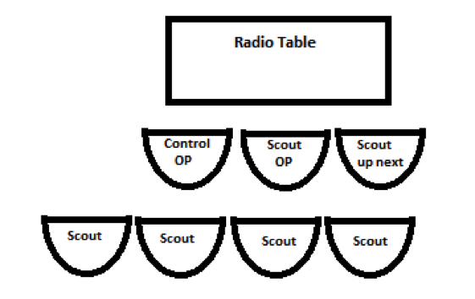

Stacking The QSO Deck
Before the first scout shows up, it would be good to have a station standing-by or have a schedule arranged in advance.
Preferably this is with a station that can be copied Q5 easily for the untrained ear, who’s English is easily understandable (extra credit if you have scout fluent in a foreign language and you can use that.
Spanish many times works out perfectly, especially to South America,
Also, it helps if the other station has a scouting background, or better yet, is another JOTA station or is at a scout camp, so you can have a scout to scout QSO.
EDGE Method of Instruction
Explain to the scouts what is going to happen.
Demonstrate by you exchanging pleasantries with the other station.
Guide the first scout in using the mic or the keyboard. Make sure they know they have to push to talk, usually end a transmission with “over” and they have to release the mic to be able to listen. Encourage them to give their first name and to use the other station’s operator’s name. This could be as simple as “Hello Alice, my name is Bob.” For those scouts that pick it up right away, try having them ID using the station’s call.
Enable them to go it alone, but have in your mind the standard question fare* that you can use to prompt the scout: have them ask what is the weather there, how old the other operator is, were they ever a scout, do they work and what do they do.
* See: 15. Have A Conversation

Often the first couple of times if copy is not good, you may have to repeat to the scout what the other station said or asked.

While you are doing the control operators duties, you also have to keep the rest of the patrol engaged with emphasis on the scout who is up next. The better this next scout is engaged, the smoother the operation will go when he is at the mic. It is important to keep your eye ahead of the game by making sure the next scout is picking up what he will have to do.

At the same time you are doing the above (and also having one ear tuned to the control operator’s duty) you should be filling out the station log, noting who has been on the air (probably just the unit number, the patrol or den and the first name) and filling the takeaway certificate if any.

Encourage all scouts to rotate into the up next position and then to the operating position but do not force any scout to talk on the air.
- If this is one of the items that count for points at a camporee and you have the ability to influence it, you could assign more points for talking on the air.
- At the end of their turn they should thank the operator for the chat and introduce the next scout who will talk.

At the end of the patrol’s time, make sure they take all their certificates and takeaways (and their backpacks.)
Tell your support people to usher them out and to usher the next patrol or den in. Make sure to ID every 10 minutes and always thank the other station for engaging the scout.

Making Contacts
Don't try to work weak stations from remote locations. Go for stronger, more local stations that unpracticed ears can hear easily and understand.
- Local FM repeaters can be just as exciting for Scouts

Use VISUALS

ARRL Amateur Radio Map of the World (Robinson) – Item #8804
Not Free ($15.00)
http://www.arrl.org/shop/ARRL-Amateur-Radio-Map-of-the-World-Robinson/
Mount this map and display it so Scouts can put Push Pins (or little vinyl dots) on the map to show where QSOs were made.
Bring a GLOBE to demonstrate distance. Get one scout to put a finger on your QTH and another to put his finger on another station’s QTH.

Handout Materials
You need to have something that the scout can leave with that will commemorate the visit: a Patch, a QSL or eyeball QSL card, a small certificate that may fit in their pocket with one fold.
I recommend using the JOTA Certificate of Participation and Contact Log (see 9F), because it is free (except for the printing) and engages the scouts as they log their group’s QSOs while at the radio.

Targeted Brochures - The Silent Salesman
We also want to give them a “Silent Salesman”. Use brochures from the ARRL Store, and have a “Contact” Label affixed. This could be:
- Your Club, if local to the participating District (e.g. MARC/WRG for the Sleeping Giant District),
- a BSA District Contact for Amateur Radio (e.g. Shawn KB1ZNT in Lighthouse District)
- an ARRL Contact (e.g. Douglas WA1SFH – Section Youth Coordinator).
Brochure List
For Cub Scouts:
- 22 Things You Can Do (Item No. YTHF) FREE 100 (4 pack of 25 ea)
(http://www.arrl.org/shop/Ham-Radio-Youth-flyer-pack-of-25/)

For Boy Scouts:
- What Is Ham Radio? (Item No. WIHR-B) FREE 100 (4 Pack of 25 ea)
http://www.arrl.org/shop/What-is-Ham-Radio-flyer-version-B-pack-of-25/

- Scouting and Amateur Radio Leaflet (Item No. SARL) FREE 100 (4 Pack of 25 ea)
http://www.arrl.org/shop/Scouting-and-Amateur-Radio-leaflet-pack-of-25/

~~~~~~~~~~~~~~~~~~~~~~~~~~~~~~~~
For Venture Scouts:
- Do It Yourself Flyer (Item No. DIYF) FREE 100 (4 Pack of 25 ea)
http://www.arrl.org/shop/Do-It-Yourself-flyer-pack-of-25/

~~~~~~~~~~~~~~~~~~~~~~~~~~~~~~~~~~~~~

For Parents:
- What Is Amateur Radio? (Item No. WIHR-A) FREE 100 (4 Pack of 25 ea)
http://www.arrl.org/shop/What-is-Ham-Radio-flyer-version-A-pack-of-25/

And
- Anything else they want.

6. Make a “JOTA” QSL Card
What is a JOTA station without a special QSL card to commemorate the event and to send out to the stations giving you QSOs?
- You won’t need many - perhaps 20 max.
There are several programs on the internet that can help you design and print QSL cards, or you can freelance one yourself using MS Publisher.
- It can be as elaborate or simple as you choose.
Design Content
In addition to the basics (Station Callsign, QTH, exchange info boxes, QSL Manager Info.) we suggest including the following elements:
- The current year’s JOTA Patch (see Document Cover Page)
- A District or Council Patch (as appropriate)
- A picture of the QTH (Camp Picture, Camp Patch, Club Station / Club Patch / Club QTH scenery
Example:
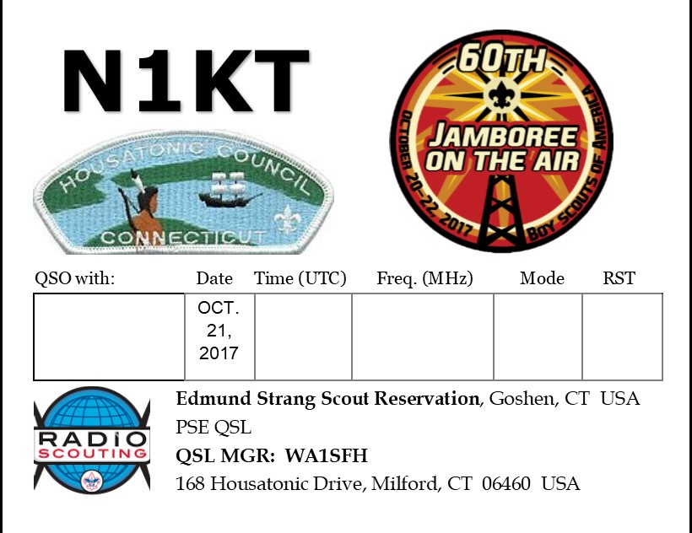
7. Sample Station ID Sheet to print out and have at the radio

Our JOTA Call Sign is
WB1DJU
(Whiskey Bravo ONE Delta Juliette Uniform)
Our QTH is
CAMP SEQUASSEN
(Sierra Echo Quebec Uniform Alpha Sierra Sierra Echo November)
in
New Harford
(I spell: November Echo Whiskey
Hotel Alpha Romeo Foxtrot Oscar Romeo Delta)

ConnecticuT
(I spell: Charlie Tango)
8. JOTA Operating Rules
All radio operators must operate their station strictly in accordance with FCC regulations.

Stations should try to contact each other by calling "CQ Jamboree" or "CQ JOTA" or by answering other stations sending this call.

Any authorized amateur radio frequency may be used. It is suggested that the frequencies listed be used, at least for a starting point/calling frequency. Once contact is established, you can move to another frequency to leave the calling frequency open for others.

Any amateur mode of operation can be used such, as CW, SSB, PSK, SSTV, FM, DMR and satellite.

The more modes in operation,
the more exciting
the event will be for the Scouts.

9. Radio Topics to Cover
Keep It Simple !
- Top Level
- Non Technical
- Inter-Active

9a. TELL THEM WHAT THEY ARE GOING TO DO
Good morning! / Good Afternoon!
Welcome to the Boy Scout Jamboree On The Air Event Station.
Jamboree On The Air, what we call JOTA (“JOE-TAH”), is the LARGEST Scouting Event in the WORLD each year where over 1 million Scouts from 150 countries around the globe participate.

Meet our Amateur Radio Team.
These men are all licensed Amateur Radio Operators. They are here today to Share the Magic of Amateur Radio Communications with you.
(Introduce Team by first name & Callsign)

Here is what we are going to do today:
- Talk about 22 exciting Things you can do in Amateur Radio
- Learn 4 ways Radio Waves can Travel
- Demonstrate Line of Sight Communications and Repeater Use
- Introduce you to the International (NATO) Alphabet
- See how Callsign and Pre-Fixes work for Countries around the World
- Learn how to “Log” Radio Contacts
- Tell you how you can get your first Amateur Radio License.
- Have a Conversation on the Radio.
9b. “22 THINGS YOU CAN DO” (2 minutes)
- READ from the Brochure
- ADD your own brief insights / experiences

9c. How Radio Waves Travel: Speed of Light !
4 Types: (Use Hand gestures/ Graphics)
- Line of Sight,
- Ionosphere Skip,
- Tropospheric Ducting,
- Meteor/Moon Reflection.

9d. Line of Sight DEMO:
Get 3 Scouts (1 TALL, 2 Short all standing, or seat two and have #3 stand)
- Demonstrate Good Line of Sight.
Have 2 Scouts facing each other (about 6’ apart) holding their index finger pointed up, with the tip at eye level.
Good Line of Sight = Good Communications

- Demonstrate No Line of Sight
- Now, put the Tall (or Standing) Scout between the two scouts
Ask if they can see the other’s finger/antenna
No Line of Sight = No Communications

- Why we Use a Repeater
- Have Tall Scout in the middle hold an HT on top of his head.
- Ask if the two scouts can see the “Repeater”.
Give Simple explanation of Repeater operations in terms of visibility, advantage of low power in and higher power out for greater coverage.

9e. The “International” (NATO) Phonetic Alphabet

International (NATO) Phonetic Alphabet A –Z
(SHOW/PRINT Chart on Following Page)
Why important:
- Standardization,
- Improves Comprehension,
- Helpful during bad radio conditions.

Scout Challenge Activity
1) Everybody: Write down your First Name in a vertical line
2) Now: Put the Phonetic Word next to each matching letter of your name.
3) Spelling Bee
Ask each scout to say their name, and then say it using the International Phonetic Alphabet equivalents.

OPTIONAL
Do another round using their last names at your discretion based on time available or delay of previous group at the radio)

The “International” (NATO) Phonetic Alphabet

A - Alfa  B - Bravo  C - Charlie  D - Delta  E - Echo  F - Foxtrot  G - Golf  H - Hotel  I - India  J - Juliet  K - Kilo  L - Lima  M - Mike | N - November  O - Oscar  P - Papa  Q - Quebec  R - Romeo  S - Sierra  T - Tango  U - Uniform  V - Victor  W - Whiskey  X - X-Ray  Y - Yankee  Z - Zulu
9f. JOTA Certificate of Participation and Contact Log
Give one to each Scout to Log All Contacts of his group.
Teach how to fill it out…before going to the Radio Room
JOTA Contact Log Sheets for Scouts come in a variety of layouts in B&W and Color.
- They make a great memento for each Scout to take home.
NOTE: As of 8/31/19 the page was NOT updated for JOTA 2019
LINK:
https://www.scouting.org/jota/certificate/

9g. Getting Your Amateur Radio License
Easy! Middle School Students are doing it… all the time.
Just 35 questions on the test.
- Can you read a book?
- Can you memorize some basic rules?
- Can you: Add, Subtract, Multiply, and Divide?
- Can you take a multiple answer test?
Best Part is
This FCC license automatically qualifies you for the Radio Merit Badge, and it meets several requirements of other Merit Badges.

10. JOTA is NOT a “Contest”.

The idea is to contact other Scout stations and allow as many Scouts as possible to talk to other Scouts and learn about who they are and what they are doing.

Don’t Get Stuck On Achieving a High Number of QSOs
with Different Stations.
You might think about counting the number of Scouts on both sides of the QSO, rather than the number of actual different station QSOs.
Typically, we find that another JOTA station will be more than pleased you tie up the frequency with your JOTA station to have their scouts talking with your scouts.
- This station contact could last 1 hour… or more!

11. How to Call CQ on Voice

2 Ways to Call Stations

CQ JOTA
CQ JOTA
CQ JOTA
This is…… (station callsign)

And/or

CQ Jamboree
CQ Jamboree
CQ Jamboree
This is…… (station callsign)

12. JOTA Calling Frequencies (+/-)
SSB, CW, PSK31, 2M/440 FM Simplex,
D-Star, DMR, IRLP, EchoLink, APRS

HF SSB Voice
Band | WOSM Calling Frequencies | Suggested Band Segment for US Stations | Notes
80 m | 3.940  3.690(1) | 3.920 – 3.940  3.670 – 3.690 (1) | (1) Extra segment
40 m | 7.190  7.090 (2) | 7.180 – 7.200  7.270 – 7.290 | (2) 7.090 not available in Region 2
20 m | 14.290 | 14.270 – 14.290  14.320 – 14.340
17 m | 18.140 | 18.140 – 18.150
15 m | 21.360 | 21.360 – 21.400
12 m | 24.960 | 24.960 – 24.980
10 m | 28.390 (3) | 28.350 – 28.400 (3) | (3) Includes Novices  & Techs
6 m | 50.160 | - – 50.200

HF CW

Band | WOSM Calling Frequencies | Suggested Band Segment for US Stations | Notes
80 m | 3.570 (3) | 3.560 – 3.570 (3) | (3) Includes Novices & Techs
40 m | 7.030 (3) | 7.030 – 7.040 (3) | (3) Includes Novices & Techs
20 m | 14.060 | 14.050 – 14.060
17 m | 18.080 | 18.070 – 18.080
15 m | 21.140 (3) | 21.130 – 21.140 (3) | (3) Includes Novices & Techs
12 m | 24.910 | 24.900 – 24.910
10 m | 28.180 (3) | 28.170 – 28.180 (3) | (3) Includes Novices & Techs
6 m | 50.160 | 50.150 – 50.160

HF PSK-31

http://bpsk31.com

Call “CQ JOTA”.
The chart below shows the commonly used frequencies for PSK-31.

Band | Frequency | Notes
80 m | 3.580
40 m | 7.080 (4) | (4) Region 2 (USA).  7.040 to 7.060 for Regions 1 & 3
30 m | 10.142
20 m | 14.070 (5) | (5) Most activity for JOTA will be on 20 m
17 m | 18.100
15 m | 21.080 (6) | (6) Most activity can be found at 21.070
12 m | 24.920
10 m | 28.120

2 Meter FM Simplex
147.450, 147.480, 147.510, 147.540*
* Use 147.540 as Calling Channel.
- Always listen first to avoid interfering with another QSO or auxiliary or control link.
- Avoid 146.520, the National FM Simplex Calling Frequency and 146.550, which is commonly used by mobiles and RVers.
70 CM FM Simplex
446.000*, 445.950, 446.050, 446.100, 446.150 *
Use 446.000 as Calling Channel.
Always listen first to avoid interfering with another QSO or auxiliary or control link.

D-STAR
http://www.dstarinfo.com
REF033A has been allocated as a full-time JOTA/Radio Scouting D-STAR Reflector. After contact is established, stations should disconnect from REF033A and connect to one or other repeater or migrate to an unused Reflector.

SIMPLEX Channels:
145.670*, 145.640, 145.610, 438.010.

* 145.670 and 438.010 are commonly used as the National D-STAR Simplex Channels and should be used only as Calling Channels for JOTA.
Always listen first to avoid interfering with another QSO.

DMR

http://www.dmr-marc.net

All wide area Talk-Groups are permitted for use for JOTA for establishing contacts.

After contact is established, stations should utilize as few resources as possible.

For international, national, and regional QSO's, stations should move their transmissions to one of the DMR-MARC UA Talk-Groups, or to the DCI TAC-310 Talk-Group.
For intrastate contacts, stations may use their area's statewide talkgroup (if applicable… eg. CT-Statewide).

The use of your repeater's local talkgroup (if applicable) is always permitted.

A full list of repeaters and their available talkgroups can be found at http://www.dmr-marc.net/repeaters.html .
SIMPLEX Channels:

441.0000*, 446.5000, 446.0750, 433.4500, 145.7900*, 145.5100.

All simplex frequencies operate on time-slot 1 and use color code 1. (*are commonly used as the National DMR Simplex Channels and should be used only as Calling Channels for JOTA.

Always listen first to avoid interfering with another QSO.)

IRLP
http://irlp.net
http://www.irlptopics.net
Use Topic Channel Node 9091 as a Common Meeting Place or Calling Channel. After contact, disconnect from 9091 and one station should connect to another's local node.

EchoLink

http://www.echolink.org
Software or apps available for Windows, Mac, iPhone/iPad, and Android. Dedicated Conference Node *JOTA-365* (node 480809). When contact is made on a Conference Node, it is recommended the two parties establish direct contact with each other to free up the Conference Node.

APRS
144.39
http://aprs.org
http://aprs.org/cqsrvr.html
http://www.aprs-is.net/CQSrvr.aspx
CQSRVR: CQ JOTA
CQSRVR: CQ SCOUTS (other times of the year)

13. 3rd Party Agreements & Scouting Countries
This is a complete list of the countries where Scouting exists.
The asterisks (*) mark countries that have third-party operating agreements with the U.S. This means people other than the licensed amateur radio operator can send messages or talk with others via amateur radio communication between the U.S. and that country.
- Albania  - Algeria  - Angola  - Argentina*  - Armenia  - Aruba  - Australia  - Austria  - Azerbaijan  - Bahamas  - Bahrain  - Bangladesh  - Barbados  - Belarus  - Belgium  - Belize*  - Benin  - Bhutan  - Bolivia*  - Bosnia and Herzegovina*  - Botswana  - Brazil*  - Brunei Darussalam  - Bulgaria  - Burkina Faso  - Burundi  - Cambodia  - Cameroon  - Canada*  - Cape Verde  - Chad  - Chile  - Colombia*  - Comoros*  - Congo  - Costa Rica*  - Croatia  - Curacao  - Cyprus  - Czech Republic  - Denmark  - Dominica*  - Dominican Republic*  - Ecuador*  - Egypt  - El Salvador*  - Estonia  - Ethiopia  - Fiji  - Finland  - France  - Gabon  - Gambia*  - Georgia  - Germany  - Ghana* | - Greece  - Grenada*  - Guatemala*  - Guinea  - Guyana*  - Haiti*  - Honduras*  - Hong Kong  - Hungary  - Iceland  - India  - Indonesia  - Ireland  - Israel*  - Italy  - Ivory Coast  - Jamaica*  - Japan  - Jordan*  - Kazakhstan  - Kenya  - Kiribati  - Kuwait  - Latvia  - Lebanon  - Lesotho  - Liberia*  - Libya  - Liechtenstein  - Lithuania  - Luxembourg  - Macedonia  - Madagascar  - Malawi  - Malaysia  - Maldives  - Malta  - Mauritania  - Mauritius  - Mexico*  - Moldova  - Monaco  - Mongolia  - Montenegro  - Morocco  - Mozambique  - Namibia  - Nepal  - Netherlands  - Netherlands Antilles  - New Zealand  - Nicaragua*  - Niger  - Nigeria  - Zimbabwe  - Zambia | - Norway  - Oman  - Pakistan  - Palestinian Authority  - Panama*  - Papua New Guinea  - Paraguay*  - Peru*  - Philippines*  - Poland  - Portugal  - Qatar  - Romania  - Russian Federation  - Rwanda  - St. Lucia*  - St. Vincent and the Grenadines*  - San Marino  - Saudi Arabia  - Senegal  - Serbia  - Seychelles  - Sierra Leone*  - Singapore  - Slovakia  - Slovenia  - South Africa*  - South Korea  - Spain  - Sri Lanka  - Sudan  - Surinam  - Swaziland*  - Sweden  - Switzerland  - Syrian Arab Republic  - Taiwan  - Tajikistan  - Tanzania  - Thailand  - Togo  - Trinidad and Tobago*  - Tunisia  - Turkey*  - Uganda  - Ukraine  - United Arab Emirates  - United Kingdom*  - United States  - Uruguay*  - Venezuela*  - World Scout Bureau, HB9S  - Yemen

14. Support Materials
RADIO WAVES
HF Signals can “Bounce”
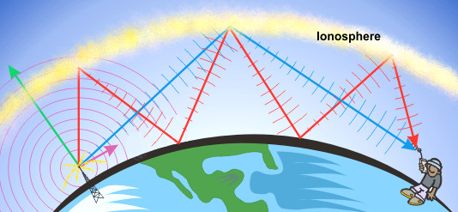

VHF/UHF Signals “Line Of Sight”
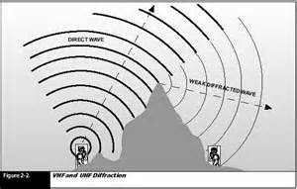

How to Participate in JOTA-JOTI
by Jim, K5ND
http://jotajoti.info/how-to-participate-in-jota-joti/
15. LET’S HAVE A “CONVERSTATION”
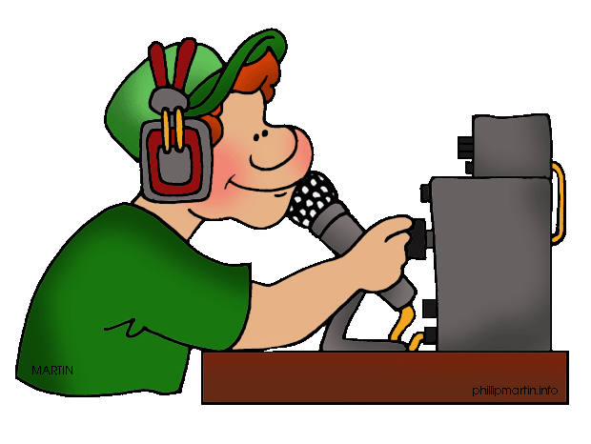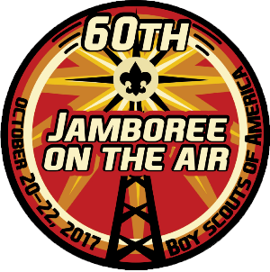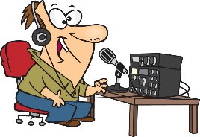
You will be talking to other Scouts or Amateur Radio Operators
TELL a little about yourself… THEN, Ask a Question.

Hi! My Name is _____________ (First Name Only)
I am ____Years Old, and I am in ____ Grade
I have been in Scouting for ___________ years,
I am a _____________RANK
In Troop/Pack/Den # ________
from __________________(TOWN) in Connecticut.
I recently completed the _____________ Merit Badge.
Right now, I am working on the ____________Merit Badge
OR :
I am working on completing the requirements of____________, to Advance to the RANK of __________.
Now,
Ask a Question about the other Person.
15a. Questions to ask an Amateur Radio Operator.
- How long have you been a Ham?

- What got you interested in getting your Amateur Radio License?
- What do you like doing most in Amateur Radio?

- Do you use Morse Code?
- What has been your furthest DX (long distance) contact?

- What has been your most exciting radio contact?

- Have you talked to the Astronauts on the International Space Station?

- Do you build any of your own radio equipment, accessories or antennas?
IF YES: What has been your most rewarding project build?

- Do you operate “Portable”?
IF YES: What sort of places to you like to operate from?
- Do you have a ham radio in your car or truck?
IF YES: Do you operate “HF” or VHF and UHF or all three?

- Are you involved in the Emergency or Disaster aspects of Ham Radio like the ARES (AIR-EZE), or RACES (RACE-EZE), or the National Traffic System?
IF YES, Have you been deployed someplace to provide Radio Communications or operated from home having been activated?

- Do you operate Digital-Data Modes?
IF YES: Which ones?

- Have you played with MESH Networking?
IF YES: What has been your longest point to point contact?
- Have you worked any Satellites?

- Have you tried Earth – Moon – Earth communications?

- Have you done any Meteor Scatter communications?

- Are you a “Contester”?
IF YES: What do you like most about “contesting”

15b. 47 Questions to ask another Scout.

1. What is your favorite thing to do in scouts?
2. What rank are you ?
3. What is your troop/pack?
4. How long have you been a scout?
5. Are you going to try to get your Eagle?
6. Why did you join the scouts?
7. What city do you live in ?
8. What state / country were you born in?
9. What have you learned in merit badge class?
10. What is the last merit badge you earned?
11. What did you have to do to earn it?
12. What was the first merit badge you earned?
13. How many merit badges have you earned?
14. What is the next merit badge are you going to try to earn?
15. What is your favorite thing in school?
16. Who is your favorite teacher?
17. What grade are you in?
18. What is your favorite car?
19. What is your favorite pet?
20. What is your favorite food?
21. What is your favorite drink?
22. What do you like to do for fun/hobby?
23. What did you do for the summer?
24. Do you know anyone that is a ham radio operator?
25. How many scouts are in the merit badge class?
26. Did you go to the National Scout Jamboree?
27. Have you lived in any other states?
28. Have you lived in another country?
29. Have you visited another country?
30. What to you want to do when you graduate from school?
31. What is your favorite sport?
32. What is your favorite team?
33. What kind of music do you listen to?
34. Who is your favorite band/singer?
35. What is your favorite movie?
36. Who is your favorite actor/actress?
37. What is your favorite video game?
38. What is your favorite TV show?
39. Do you play sports? What sport?
40. Do you have brothers or sisters?
41. What is your least favorite thing in school?
42. Why are you taking radio merit badge?
43. What Boy Scout camps have you been to?
44. What is your favorite color?
45. How many scouts in your troop/pack?
46. Coolest trip your Troop/Pack has been on?
47. How many knots can you tie from memory?

